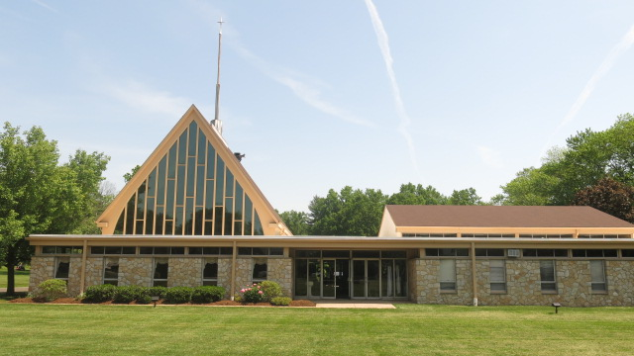
Heidelberg United Church of Christ
1101 Cowpath Road
Hatfield, Pennsylvania 19440
215-368-0442
Website: HeidelbergUCC.org
YouTube Channel: Heidelberg Church
https://www.youtube.com/channel/UCGs7NVqlzGz0y2brQQS9ghw
Rev. Dr. Marianne Unger, Pastor
Susan Camuso, Minister Of Music
Nancy Kohler, Secretary
Secretary@HeidelbergUCC.org

…A Faith Community with a Place for You!

Worship For The Third Sunday Of Easter, April 26, 2020 Live-Stream
Worship Assistant: Rev. Dr. John Lepera

WELCOME

JOYS AND CONCERNS (10:45 – 10:55 a.m.)

RINGING OF THE BELL

PRELUDE: “Give Thanks” - Ashley Paskill, Flute Soloist

OPENING HYMN: “In The Garden”

SOLEMN DECLARATION

CALL TO WORSHIP: “Turn Your Eyes Upon Jesus”

INVOCATION (ALL)
Wondrous God, present with us when we do not know it, valuing us when we do not care for ourselves, planting in us the seed of your word even when the soil of our hearts is hard and unyielding, open our eyes to recognize you here. May we sense your presence next to us. May we hear your voice. May we know your touch. May we see you in one another and in the beauty all around us. May your reality emerge deep inside each life, transforming our thoughts and deeds and our relationship with one another. Amen

CALL TO CONFESSION (PASTOR)
Peter preached: “Save yourselves from this crooked generation. Repent … so your sins may be forgiven.” We participate in our society’s alienation from God. We have joined the “me” generation in putting our own interests before all else. We have much to confess before we can claim the wholeness God offers.
(Moment of Silent Prayer)

PRAYER OF CONFESSION (ALL)
O God, we confess that we rush through our days without recognizing your presence with us. We follow our busy diversions without reference to your will for us. We strive for financial success and personal recognition, while you call for obedience to truth and genuine mutual love. Purify our souls, we pray, and redirect our priorities. May we be born anew through your living and enduring word. Amen.

KYRIE:
Pastor: Lord, have mercy upon us.
People: Lord, have mercy upon us.
Pastor: Christ, have mercy upon us.
People: Christ, have mercy upon us.
Pastor: Lord, have mercy upon us.
People: Lord, have mercy upon us.

ASSURANCE OF PARDON (PASTOR)
The promise of forgiveness is for us and for our children, for everyone whom God calls. The gift of the Holy Spirit is ours to receive. Lift up the cup of salvation every day, and call on God’s name. Give thanks for the words and deeds of Jesus, who revealed God’s love for us and enlists us as disciples and apostles.

CHORAL RESPONSE # 29 “Glorify Thy Name”
Father, we love You, we worship and adore You,
Glorify Thy name in all the earth.
Glorify Thy name, glorify Thy name,
Glorify Thy name in all the earth.

APOSTLES CREED
I believe in God the Father Almighty, maker of heaven and earth:
And in Jesus Christ His only Son, our Lord; who was conceived by the Holy Spirit, born of the Virgin Mary, suffered under Pontius Pilate, was crucified, dead, and buried; He descended into hades; the third day He rose again from the dead; He ascended into heaven, and sitteth on the right hand of God, the Father Almighty; from thence He shall come to judge the quick and the dead.
I believe in the Holy Spirit, the holy Christian church, the communion of saints, the forgiveness of sins, the resurrection of the body, and the life everlasting. Amen.

COLLECT

HOLY SCRIPTURES:
Old Testament: Psalm 116: 1-4, 12-19
Epistle: I Peter 1:17-23
Gospel: Luke 24:13-35

SERMON: “Encountering The Risen Christ!”

SERMON HYMN: “Put Your Hand In The Hand”

PASTORAL PRAYER

THE LORD’S PRAYER (ALL)
Our Father, who art in heaven, hallowed be Thy Name. Thy kingdom come. Thy will be done on earth as it is in heaven. Give us this day our daily bread. And forgive us our debts, as we forgive our debtors. And lead us not into temptation, but deliver us from evil. For thine is the kingdom, and the power, and the glory, forever. Amen.

OFFERING

OFFERTORY RESPONSE: # 625 “Doxology”
Praise God from whom all blessings flow;
Praise Him, all creatures here below,
Praise Him above, ye heav’nly host;
Praise Father, Son, and Holy Ghost. Amen.

PRAYER OF DEDICATION (ALL)
Thank you, God, for the privilege of joining with Christ in the proclamation of your love for all people. May the ministries we support serve to unite people across all differences, building up the body of Christ and reaching out to the world with healing energy. Bless these gifts and all who give to make your love known. Amen.

BENEDICTION

FOUR-FOLD AMEN

CLOSING HYMN: “Hallelujah”

We carry the light of Christ out into the world.

