Heidelberg United Church of Christ
… A Faith Community With a Place for You!
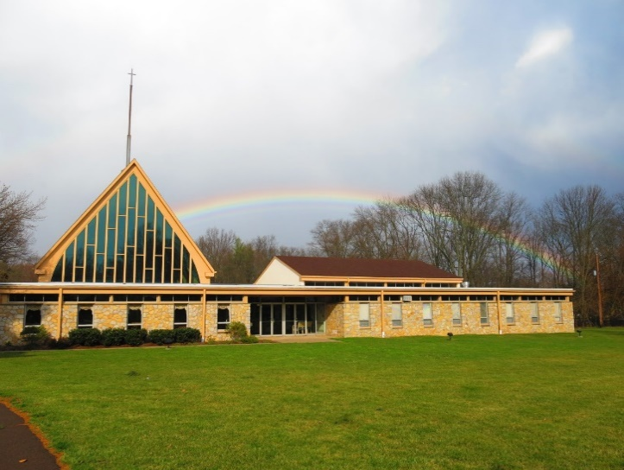

1101 Cowpath Road
Hatfield, PA 19440
215-368-0442

Welcome!

Pastor  Secretary  Website: | Rev. Dr. Marianne Unger  revm123@gmail.com  610-715-7984  Nancy Kohler  secretary@heidelbergucc.org  215-368-0442  HeidelbergUCC.org



Our Mission Statement
The mission of Heidelberg United Church of Christ is to know our Savior and to let Him work through us as we reach out in worship, service, and witness to all.
Our Vision Statement
As Heidelberg United Church of Christ, we hear God calling us to accomplish the vision He has provided through: broadening the base of His church’s membership within our own congregation; communicating His gospel more effectively; serving the local community with greater commitment; to grow and strengthen in the faith with which God has entrusted us; and, in obedience to His command and call, ministering in those ways that will assure the growth and enrichment of congregational identity and Christian discipleship.

We Welcome You to Heidelberg United Church of Christ, Hatfield …

… A Faith Community With a Place for You
Sunday September 19, 2021 10:45 a.m.
seventeenth Sunday After Pentecost

Ringing of the Bell
Welcome
Announcements/Birthday Celebrations
Joys and Concerns
If you cannot hear the details of the joys or concerns and want to know more, please speak to the individual sharing the concern after worship.
Prelude: “Jesus Calls Us” - arr. Wood

* Those who are able, please stand

* Opening Hymn: NO. 234
“Crown Him with Many Crowns”
* Solemn Declaration
* Call to Worship
“Breathe On Me Breath of God”
Breathe on me Breath of God,
Until my heart is pure,
Until my will is one with Thine,
To do and to endure.

Invocation (All)
You watch over us, O God, and show us the way to prosper in life, not so much in things as in relationships that contribute to our wholeness and well- being. Thank you for meeting us here and helping us to deal with our selfish ambition, disorder, and conflicts. We submit ourselves to you for instruction, help us to be honest with ourselves and with you, voicing our doubts as well as our faith, our hypocrisy along with all that is deeply genuine. Create in us a space for quiet listening and thoughtful meditation. Amen.
Call to Confession (Pastor)
We are called to resist evil and to purify our hearts. Often our need for such cleansing is not apparent to us. We are hard pressed to find anything bad that we need to confess, and we take real delight in the good we have done. Yet the peaceful community God seeks, the serving church that embodies Christ, the spirit-filled company we are meant to be, are not yet realized. Our Prayer of Confession is for the whole people of God, including ourselves. (Silent Meditation)
Prayer of Confession (All)
Forgive us, God, for our complacent attitudes and self-serving comforts. We do not relish the thought of sacrificing for some larger good we cannot see, for people with whom we find it difficult to identify. We compare ourselves favorably against many who seem less attuned to your purposes than we, forgetting that our true standard is Christ Jesus. We ask you to take from us all bitterness, envy, and anger that stands in the way of your reign. May all we ask of you be for the common good of all your children. Amen.
Kyrie:
Pastor: Lord, have mercy upon us.
People: Lord, have mercy upon us.
Pastor: Christ, have mercy upon us.
People: Christ, have mercy upon us.
Pastor: Lord, have mercy upon us.
People: Lord, have mercy upon us.
* Assurance of Forgiveness (Pastor)
God, who tries our hearts and minds, judges righteously, hears our prayers, and forgives and upholds us, in our daily meditation, God meets us, and in our encounters with one another, God’s presence is revealed in unexpected ways to those who are alert and receptive. Nourished by the streams of living water which our God provides, we will prosper in the work God gives us to do.
* Choral Response NO. 623
“Gloria Patri”
Glory be to the Father,
And to the Son, and to the Holy Ghost:
As it was in the beginning,
Is now, and ever shall be,
World without end* Amen, Amen.
Apostles Creed
I believe in God the Father Almighty, maker of heaven and earth: And in Jesus Christ His only Son, our Lord; who was conceived by the Holy Spirit, born of the Virgin Mary, suffered under Pontius Pilate, was crucified, dead, and buried; He descended into hades; the third day He rose again from the dead; He ascended into heaven, and sitteth on the right hand of God, the Father Almighty; from thence He shall come to judge the quick and the dead. I believe in the Holy Spirit, the holy Christian church, the communion of saints, the forgiveness of sins, the resurrection of the body, and the
life everlasting. Amen.
Collect Bill Brown
Psalm 1
James 3:13-4:3, 7-8a
Mark 9:30-37
Sermon: "Servant Ministry"
*Sermon Hymn: “It Is Well With My Soul” NO. 493
Pastoral Prayer
The Lord’s Prayer (All)
Our Father, who art in heaven, hallowed be Thy Name. Thy kingdom come. Thy will be done on earth as it is in heaven. Give us this day our daily bread. And forgive us our debts, as we forgive our debtors. And lead us not into temptation, but deliver us from evil. For thine is the kingdom, and the power, and the glory, forever. Amen.
Offertory: “Rock of Ages” - arr. Wood
Offering
Offertory Response NO. 625

“Doxology”

Praise God from whom all blessings flow;
Praise Him, all creatures here below,
Praise Him above, ye heav’nly host;
Praise Father, Son, and Holy Ghost. Amen.
* Prayer of Dedication (All)
We who have spent much on our own pleasures are pleased to share that other may obtain the necessities of body and spirit. Thank you, God, for this opportunity to support the ministry and mission of our congregation. May there be a harvest of righteousness among us, shown in the peaceful handling of disputes, in mutual love and support, and in courageous outreach to people near and far who need the help we can give. Bless each gift and giver. Amen.
* Benediction
* Four-Fold Amen
* Closing Hymn: “When We All Get To Heaven” NO.542

We carry the light of Christ into the world.

*POSTLUDE: “Prelude and Fugue in F Major” - Bach

Welcome to Heidelberg!
It is a pleasure to have you with us, and we hope your worship experience with us is meaningful. If you are a visitor, please see an usher for a “Welcome” packet if you did not already receive one. We want to get to know you!
* * * A N N O U N C E M E N T S * * *
Our Organist today is Paul Daniels.
On Sunday. October 3rd, we will resume our monthly Sunday Morning Prayer Breakfast at 8:30 am in Light Hall. Everyone is invited to attend as we join in prayer for those in need.
We have many openings for sponsoring Flowers and Bulletins. Please sign the charts in Narthex or let Nancy know what dates you choose.
The Communitas newsletter is available online at PSEC.org under the "Events & News” heading.
Attendance 9/12/21 –50 in House 50 Live stream

Pastor’s Office Hours
Monday Day Off
Tuesday 1:00 – 4:00 and 6:00 - 9:00 pm
Thursday 11:00 - 3:00
Friday 11:00 – 3:00

Please note if an emergency arises, Pastor will not be in the office while she addresses the emergency.



Tuesday Sept 14: “Hope” (puppets) practice 6-7 pm
Wednesday Sept 22: Choir Practice 6:30- 7:30 pm
Thursday Sept 23: Confirmaton Class 6:30- 7:30 pm
Sunday September 26: Sunday School Teacher Installation
Sunday October 3: Prayer Breakast 8:30am.
World Wide Communion
**********************
9/26 Habitat For Humanity Ground Breaking
Music by the Manatees, food, bounce house, face painting, Touch a Truck ,tours. 12-4 pm

